**TAI CHI FOR ARTHRITIS & FALLS PREVENTION**

Designed for people 60 and older to improve strength and balance; to reduce fear and risk of falling; to be more relaxed, flexible, and socially engaged; and to utilize these skills in activities of daily living.

All ambulatory people are welcome, including people in chairs. Class lasts for an hour and focuses on balance and mindfulness.

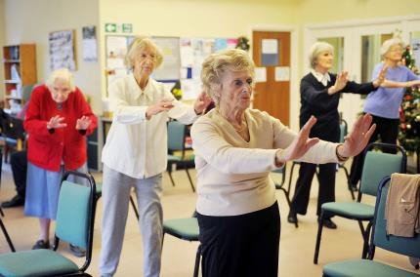

Wednesday & Fridays

Starting June 13th

10:00 – 11:00am

# Class size may be limited.

# Donations are appreciated

Location: Lovell United Church of Christ, 1174 Main St. Lovell (located in the community room downstairs)

# Instructors: Nancy Noppa & Merrill Bittner - SeniorsPlus Volunteers

**Advance registration required:**

Please call SeniorsPlus at 1-800-427-1241 and ask for Cecilia Natale