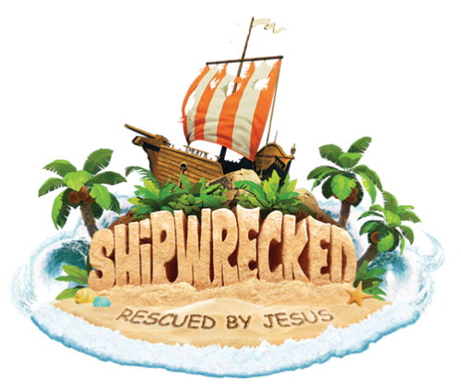
Crew Name (for church use only): __________________________________

REGISTRATION FORM
(One Per Child)

Child’s name: ____________________________________________________Child’s Gender _________

Child’s age: _________ Date of birth: _________________ School Grade entering in the Fall _______

Name of parent(s): _____________________________________________________________________

Mailing Address: ______________________________________________________________________

City: ____________________________________________State_______ ZIP _____________________

Home telephone: (______) ___________________________

Parent/caregiver/s cellphone: (________) ____________________________

Home email address: ____________________________________________________________

Home church: _________________________________________________________________________

Allergies or other medical conditions: ________________________________________________

_______________________________________________________________________________

In case of emergency, contact: _________________________________________

Phone: ___________________________________________________________

Relationship to Child: _______________________________________________

PHOTO/MEDIA/WEBSITE RELEASE
I hereby consent to the use of my child’s name, likeness and speech in audio tape, video tape, film or photograph made during the Lovell United Church of Christ Vacation Bible School Program for the church or for publicity purposes. I expressly release the Lovell United Church of Christ from any privacy, defamation, other claims arising out of broadcast, exhibition, publication or promotion of this program.

________________________________________ ____________________________________
Parent/Guardian’s Name (Print) Parent/Guardian’s Name (Signature)

