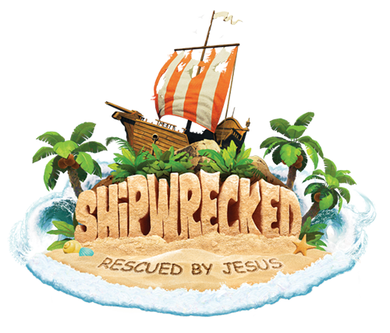

The best week of the summer!
New friends Amazing experiments
Creative games Tropical treats
Surprising adventures Incredible music

LOVELL UNITED CHURCH OF CHRIST, CENTER LOVELL, ME
Vacation Bible School
June 25-June 29, 2018
9:30-1:30
Ages 3 and Up

- Register online at vbspro.events/p/lucc
or contact the church for a paper copy

- For more information, call:
Vicki: 925-1444 or the Church: 925-1321

