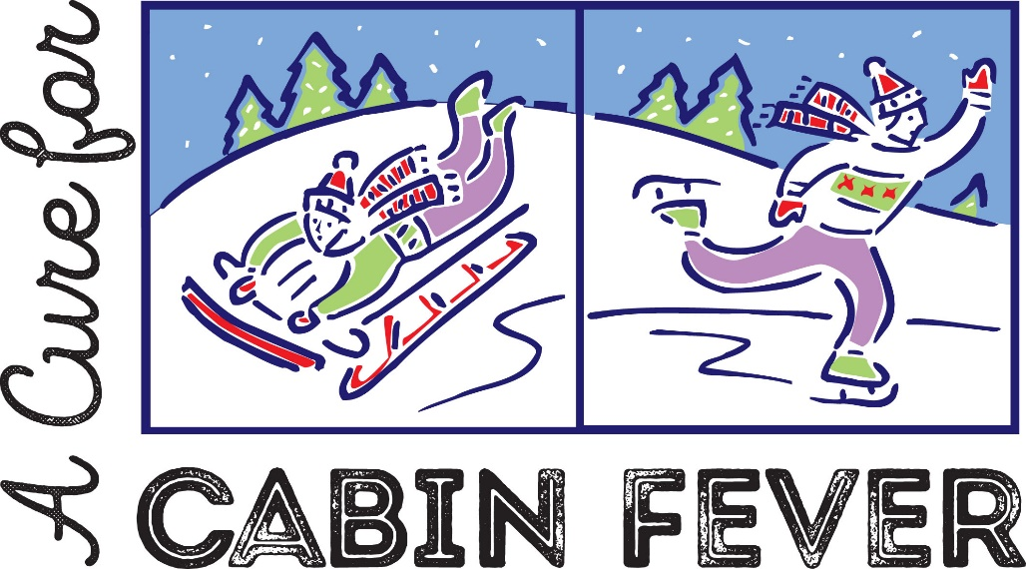

When: Friday, February 28, 5:30 pm
Where: Lovell United Church of Christ
1174 Main St.
Lovell, Maine
What: Soup, salad, sandwiches and cookies for dinner followed by a
fun variety show for entertainment

This event is FREE and all are welcome!

*If you have “talent act” to share, please sign up with Carolyn Carter 928-2080

